Stand Together

Sign the Petition to
say NO to mandatory COVID testing
Then visit the website: www.findcovidtruth.weebly.com
To print the opt-out form
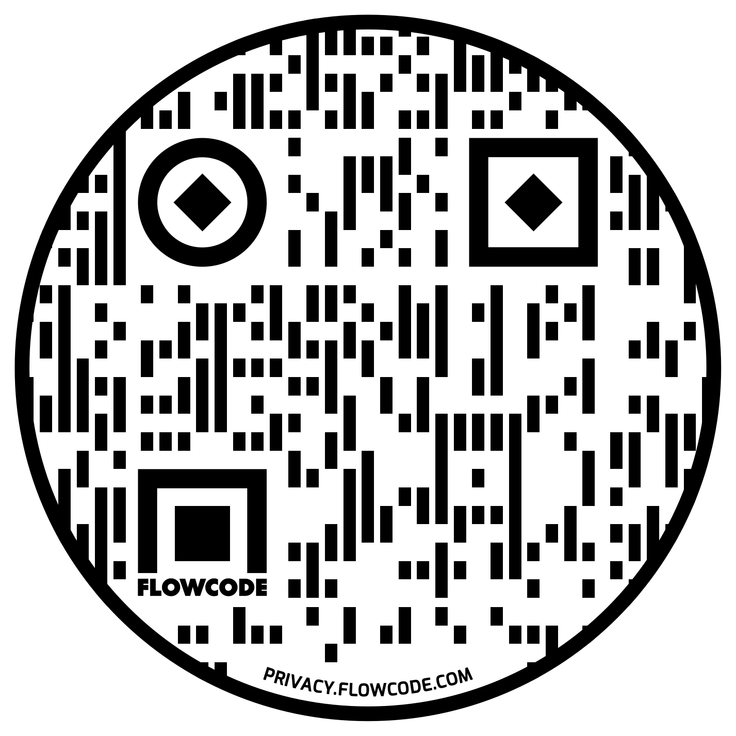

Stand Together

Sign the Petition to
say NO to mandatory COVID testing
Then visit the website: www.findcovidtruth.weebly.com
To print the opt-out form

Stand Together

Sign the Petition to
say NO to mandatory COVID testing
Then visit the website: www.findcovidtruth.weebly.com
To print the opt-out form

Stand Together

Sign the Petition to
say NO to mandatory COVID testing
Then visit the website: www.findcovidtruth.weebly.com
To print the opt-out form

